EXPERIMENT 14
5G-Oriented Decimation and Interpolation for Multirate mmWave Signal Processing Using MATLAB
Digital Signal Processing Laboratory
EXPERIMENT DETAILS
Experiment Number | 14
Date | 12 October 2026
Name / Register Number | Lokesh A (192512293)
Programme | B.E. Electronics and Communication Engineering (ECE)
1. AIM
To implement a 5G-oriented multirate signal-processing system in MATLAB using FIR anti-aliasing and anti-imaging filters, decimation by a factor of 4, and interpolation by a factor of 2, and to examine the resulting signal spectra and filter performance.
2. OBJECTIVES
- Generate a baseband multitone signal containing 15 MHz and 35 MHz components.
- Design and apply an FIR low-pass anti-aliasing filter before decimation.
- Reduce the sampling rate from 1000 MHz to 250 MHz using M = 4.
- Upsample the decimated signal by L = 2 and apply an anti-imaging FIR filter.
- Evaluate passband ripple and stopband attenuation and plot the signal spectra.
3. SOFTWARE AND PARAMETERS
Parameter | Value | Unit / Description
Nominal carrier frequency | 28 | GHz (nominal; not generated as an RF waveform)
Input sampling frequency | 1000 | MHz
Decimation factor (M) | 4 | Factor
Decimated sampling frequency | 250 | MHz
Interpolation factor (L) | 2 | Factor
Output sampling frequency | 500 | MHz
Input signal length | 4000 | Samples
FIR filter order | 60 | Order
Input tones | 15 and 35 | MHz
4. MATLAB PROGRAM

clear; clc; close all;

%% EXPERIMENT 14: 5G-LIKE MULTIRATE SIGNAL PROCESSING

%% 1. PARAMETER DEFINITIONS
fc_carrier = 28e9; % Nominal carrier frequency (28 GHz)
Fs_in = 1000e6; % Input sampling frequency (1000 MHz)
M = 4; % Decimation factor
L = 2; % Interpolation factor

Fs_dec = Fs_in/M; % 250 MHz
Fs_out = Fs_dec*L; % 500 MHz

N_samples = 4000;
N_fir = 60;

f1 = 15e6;
f2 = 35e6;

t_in = (0:N_samples-1)/Fs_in;
x_in = sin(2*pi*f1*t_in) + 0.5*cos(2*pi*f2*t_in);

%% 2. DECIMATION: ANTI-ALIASING FILTER
fc_dec = 0.25; % Normalized cutoff: 125 MHz
b_dec = fir1(N_fir, fc_dec, 'low');

x_filtered_dec = filter(b_dec, 1, x_in);
x_dec = x_filtered_dec(1:M:end);

%% 3. INTERPOLATION: UPSAMPLING AND ANTI-IMAGING FILTER
x_up = zeros(1, length(x_dec)*L);
x_up(1:L:end) = x_dec;

fc_interp = 0.5; % Normalized cutoff: 125 MHz
b_interp = fir1(N_fir, fc_interp, 'low');
x_out = L*filter(b_interp, 1, x_up);

%% 4. FILTER PERFORMANCE ANALYSIS
Nfreq = 16384;
[H_dec, f_dec_filter] = freqz(b_dec, 1, Nfreq, Fs_in);
H_dec_db = 20*log10(max(abs(H_dec), 1e-12));

pb_idx = f_dec_filter <= 0.8*(Fs_dec/2);
sb_idx = f_dec_filter >= Fs_dec/2;

passband_ripple = max(H_dec_db(pb_idx)) - min(H_dec_db(pb_idx));
stopband_atten = -max(H_dec_db(sb_idx));

%% 5. COMMAND WINDOW RESULTS
fprintf('\\n============================================\\n');
fprintf(' EXPERIMENT 14: MULTIRATE PROCESSING\\n');
fprintf('============================================\\n');
fprintf('Nominal Carrier Frequency : %.2f GHz\\n', fc_carrier/1e9);
fprintf('Input Sampling Rate : %.2f MHz\\n', Fs_in/1e6);
fprintf('Decimation Factor (M) : %d\\n', M);
fprintf('Decimated Sampling Rate : %.2f MHz\\n', Fs_dec/1e6);
fprintf('Interpolation Factor (L) : %d\\n', L);
fprintf('Output Sampling Rate : %.2f MHz\\n', Fs_out/1e6);
fprintf('\\nSIGNAL LENGTHS\\n');
fprintf('Original Signal : %d samples\\n', length(x_in));
fprintf('Decimated Signal : %d samples\\n', length(x_dec));
fprintf('Upsampled Signal : %d samples\\n', length(x_up));
fprintf('Interpolated Output : %d samples\\n', length(x_out));
fprintf('\\nDECIMATION FILTER PERFORMANCE\\n');
fprintf('Passband Ripple : %.4f dB\\n', passband_ripple);
fprintf('Stopband Attenuation : %.4f dB\\n', stopband_atten);

%% 6. OUTPUT PARAMETER TABLE
Parameter = {
'Nominal Carrier Frequency'
'Input Sampling Frequency'
'Decimated Sampling Frequency'
'Interpolated Sampling Frequency'
'Decimation Factor'
'Interpolation Factor'
'Original Signal Length'
'Decimated Signal Length'
'Interpolated Output Length'
'Passband Ripple'
'Stopband Attenuation'
};

Value = [
fc_carrier/1e9
Fs_in/1e6
Fs_dec/1e6
Fs_out/1e6
M
L
length(x_in)
length(x_dec)
length(x_out)
passband_ripple
stopband_atten
];

Unit = {
'GHz'
'MHz'
'MHz'
'MHz'
'Factor'
'Factor'
'Samples'
'Samples'
'Samples'
'dB'
'dB'
};

disp(table(Parameter, Value, Unit));

%% 7. FFT-BASED SPECTRUM CALCULATION
Nfft = 8192;

X_in = fft(x_in, Nfft);
f_in = (0:Nfft/2)*Fs_in/Nfft;
mag_in = abs(X_in(1:Nfft/2+1));
mag_in_db = 20*log10(max(mag_in/max(mag_in), 1e-8));

X_dec = fft(x_dec, Nfft);
f_dec = (0:Nfft/2)*Fs_dec/Nfft;
mag_dec = abs(X_dec(1:Nfft/2+1));
mag_dec_db = 20*log10(max(mag_dec/max(mag_dec), 1e-8));

X_out = fft(x_out, Nfft);
f_out = (0:Nfft/2)*Fs_out/Nfft;
mag_out = abs(X_out(1:Nfft/2+1));
mag_out_db = 20*log10(max(mag_out/max(mag_out), 1e-8));

%% 8. FIGURE 14A: ORIGINAL SIGNAL
figure('Name', 'Experiment 14A: Original Signal');
subplot(2,1,1);
plot(t_in(1:200)*1e6, x_in(1:200), 'b');
grid on; xlabel('Time (us)'); ylabel('Amplitude');
title('Original Baseband Signal');

subplot(2,1,2);
plot(f_in/1e6, mag_in_db, 'b', 'LineWidth', 1.1);
grid on; xlabel('Frequency (MHz)');
ylabel('Normalized Magnitude (dB)');
title('Original Signal Spectrum');
xlim([0 Fs_in/2/1e6]); ylim([-80 5]);

%% 9. FIGURE 14B: DECIMATED SIGNAL
figure('Name', 'Experiment 14B: Decimation');
t_dec = (0:length(x_dec)-1)/Fs_dec;
idx_dec = 1:min(200,length(x_dec));

subplot(2,1,1);
plot(t_dec(idx_dec)*1e6, x_dec(idx_dec), 'r');
grid on; xlabel('Time (us)'); ylabel('Amplitude');
title('Filtered Decimated Signal');

subplot(2,1,2);
plot(f_dec/1e6, mag_dec_db, 'r', 'LineWidth', 1.1);
grid on; xlabel('Frequency (MHz)');
ylabel('Normalized Magnitude (dB)');
title('Decimated Signal Spectrum');
xlim([0 Fs_dec/2/1e6]); ylim([-80 5]);

%% 10. FIGURE 14C: INTERPOLATED SIGNAL
figure('Name', 'Experiment 14C: Interpolation');
t_out = (0:length(x_out)-1)/Fs_out;
idx_out = 1:min(200,length(x_out));

subplot(2,1,1);
plot(t_out(idx_out)*1e6, x_out(idx_out), 'm');
grid on; xlabel('Time (us)'); ylabel('Amplitude');
title('Interpolated Output Signal');

subplot(2,1,2);
plot(f_out/1e6, mag_out_db, 'm', 'LineWidth', 1.1);
grid on; xlabel('Frequency (MHz)');
ylabel('Normalized Magnitude (dB)');
title('Interpolated Output Spectrum');
xlim([0 Fs_out/2/1e6]); ylim([-80 5]);

%% 11. FIGURE 14D: FILTER RESPONSES
figure('Name', 'Experiment 14D: FIR Filter Responses');
[H_interp, f_interp_filter] = freqz(b_interp, 1, Nfreq, Fs_out);

plot(f_dec_filter/1e6, 20*log10(max(abs(H_dec),1e-12)), ...
'b', 'LineWidth', 1.2);
hold on;
plot(f_interp_filter/1e6, ...
20*log10(max(abs(H_interp),1e-12)), 'r--', 'LineWidth', 1.2);
grid on; xlabel('Frequency (MHz)'); ylabel('Magnitude (dB)');
title('Anti-Aliasing and Anti-Imaging Filter Responses');
legend('Decimation Filter', 'Interpolation Filter');
ylim([-100 5]);

%% 12. FINAL RESULT
fprintf('\\n============================================\\n');
fprintf(' FINAL RESULT\\n');
fprintf('============================================\\n');
fprintf('1. Multirate signal processing was implemented.\\n');
fprintf('2. Anti-aliasing filtering and decimation were performed.\\n');
fprintf('3. Upsampling and anti-imaging filtering were performed.\\n');
fprintf('4. FFT-based spectra were calculated.\\n');
fprintf('5. FIR filter performance was evaluated.\\n');
fprintf('Note: 28 GHz is nominal; the generated signal is baseband.\\n');
fprintf('============================================\\n');
5. PROCEDURE
- Define the nominal carrier frequency, sampling rates, conversion factors, input tone frequencies, and signal length.
- Generate the baseband multitone signal using the 15 MHz sine and 35 MHz cosine components.
- Design a 60th-order FIR low-pass filter and filter the input before decimation.
- Downsample the filtered sequence by retaining every fourth sample.
- Insert one zero between consecutive decimated samples to perform interpolation by a factor of two.
- Apply the interpolation low-pass filter and multiply its output by the interpolation factor.
- Calculate the decimation filter response, passband ripple, and stopband attenuation.
- Use FFT-based calculations to plot the original, decimated, and interpolated signal spectra.
6. OUTPUT SCREENSHOTS
The following screenshots show the MATLAB signal-processing plots and filter responses obtained for Experiment 14.
Figure 1: MATLAB output screenshots
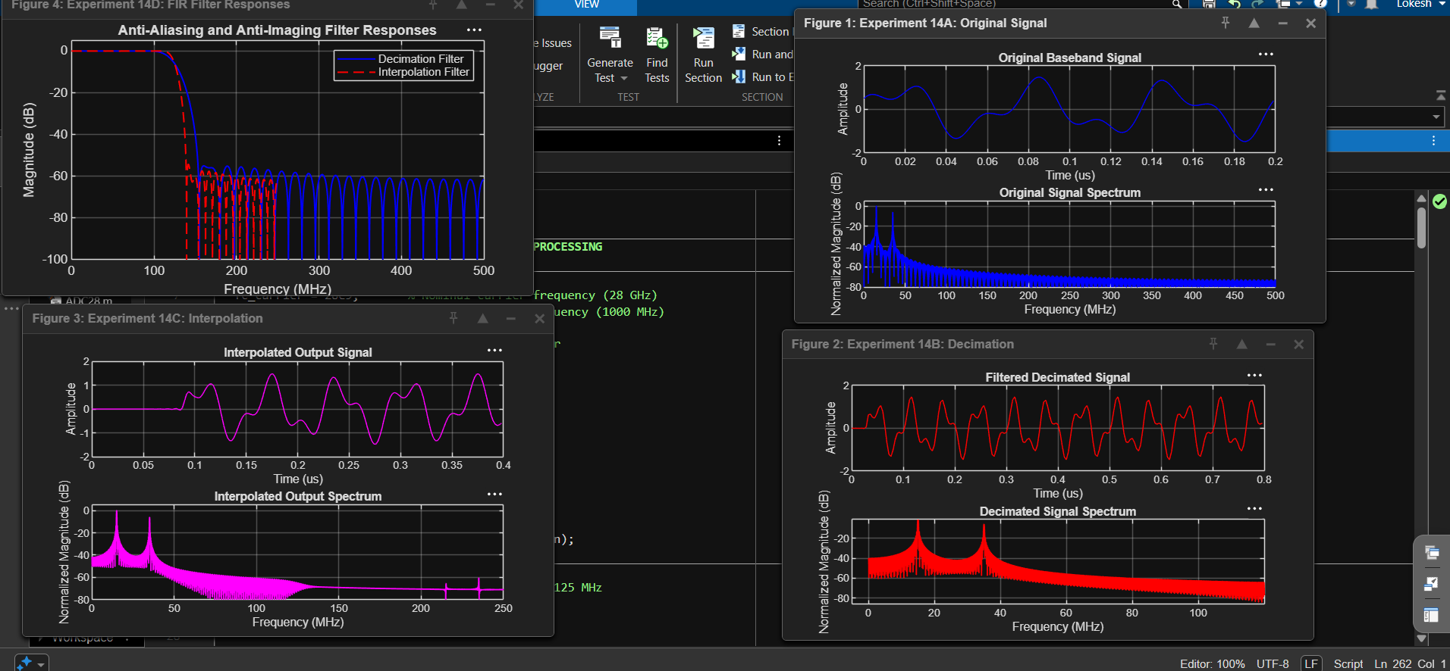

Figure 2: MATLAB output screenshots
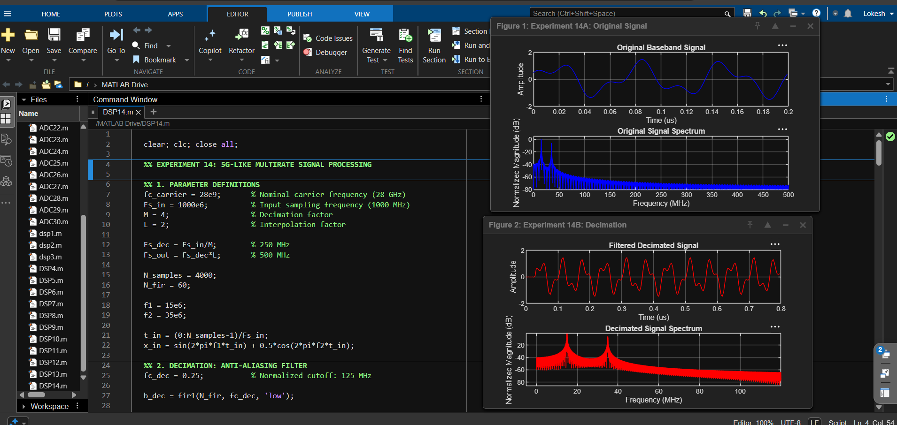
7. OBSERVATIONS AND DISCUSSION
The input signal contains two baseband frequency components at 15 MHz and 35 MHz. Decimation by four reduces the sampling frequency from 1000 MHz to 250 MHz, while interpolation by two raises the output sampling frequency to 500 MHz. The FIR filters are intended to suppress frequency components that could cause aliasing during decimation and spectral images during interpolation.
The plotted spectra are normalized independently to their own maximum magnitudes, so they are useful for comparing spectral shape but do not directly establish absolute gain preservation. Filter metrics printed by MATLAB should be copied from the actual run rather than assumed in advance.
The nominal 28 GHz carrier is included as an experiment parameter only. Since the code generates a low-frequency baseband multitone sequence, it does not simulate RF mixing, a 28 GHz carrier waveform, or a complete 5G radio link.
8. APPLICATIONS
- Multirate digital signal processing in wireless communication receivers.
- Sampling-rate conversion in baseband communication systems.
- Anti-aliasing and anti-imaging filtering in digital transmitters and receivers.
- Efficient processing of multitone and subcarrier-based signals.
- Preliminary baseband studies relevant to millimetre-wave communication systems.
9. RESULT
The MATLAB implementation performs FIR filtering, decimation by a factor of four, interpolation by a factor of two, and FFT-based spectrum visualization. The sampling rates and signal lengths are evaluated, and the decimation filter's passband ripple and stopband attenuation are calculated from its frequency response.
10. CONCLUSION
The experiment demonstrates the basic implementation of multirate signal processing using MATLAB. Anti-aliasing and anti-imaging filters are applied around the rate-conversion stages, and the resulting signal spectra are examined. The simulation represents baseband processing with a nominal 28 GHz system context rather than direct RF carrier generation.
DONE BY: Lokesh A (192512293)
B.E. Electronics and Communication Engineering (ECE)

